Cash & bank - Reports Extract
Table of content

Contents
Bank Reconcilement Report - 3 -
Bank Statement - 6 -
Chq. Payment advices - 10 -
Chq. Print Test - 17 -
External bank statements - 19 -

Bank Reconcilement Report

Post finalizing of the reconcilement process of banks records, we can generate reconcilement report for validation
Right after selecting the Bank Transaction Type & clicking the Save tab.
Once the information is saved, you can print the report by going to the Print tab and choosing Bank Reconciliation or through Inquiries & reports section using the below paths

Path :

Cash and Bank Management → Bank Accounts → Account Reconciliation → New → Enter Date & Description → Save (to activate Transactions) → Transactions → New → Select Bank Transaction Type → Save → Print → Bank Reconciliation Report
OR Cash and Bank Management → Inquires & Reports → Bank Reconcilement

Where generated bank reconcilement reports are shown as follows :

BM EG
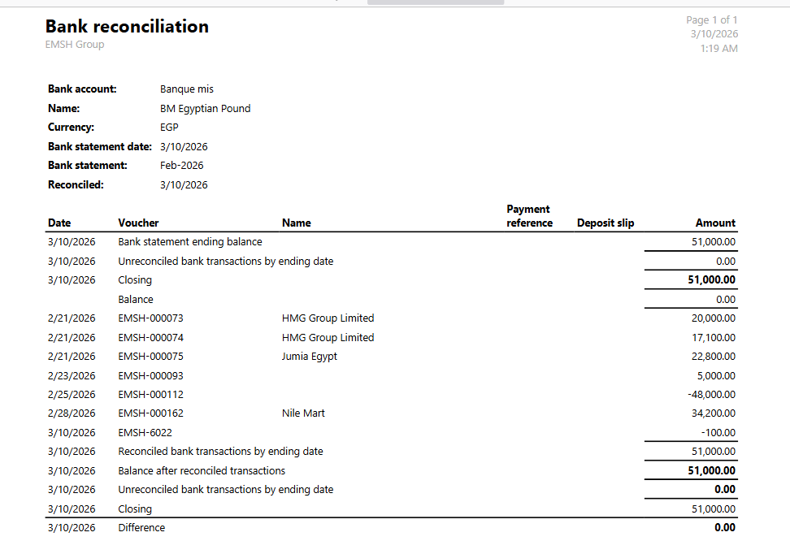

BM USD

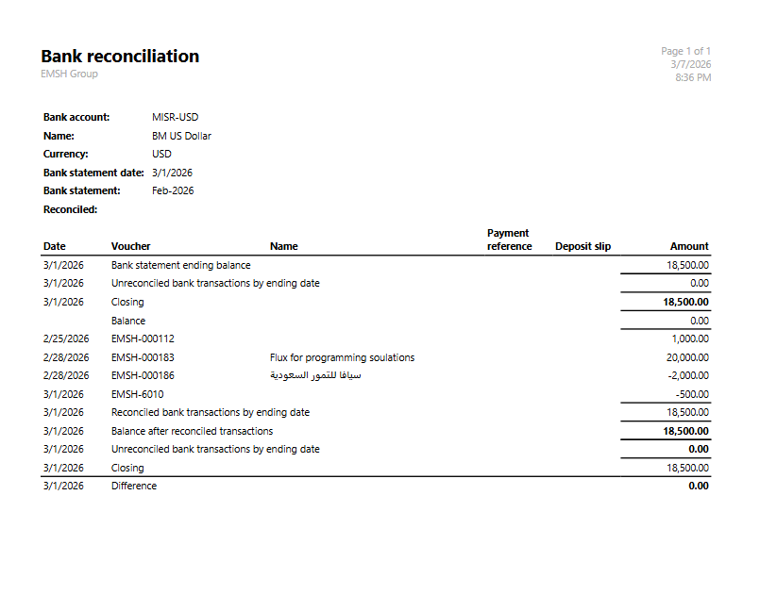

Bank Statement

To check the various ongoing transaction processed through our bank accounts , we revert to generate bank statements for certain bank accounts to be able to continuously monitor & review banks transactions, using the below path

Path :
Cash and Bank Management → Inquires & Reports → Bank Statement

Where generated bank statements are shown as follows :

CUB EG 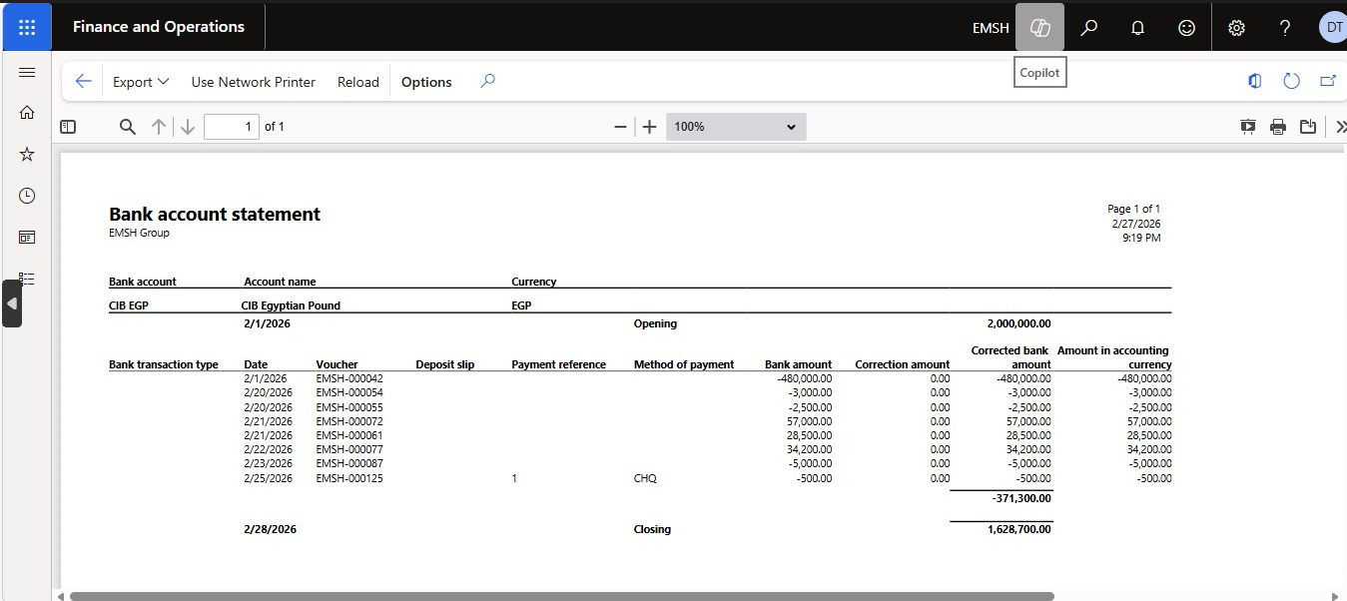

BM USD
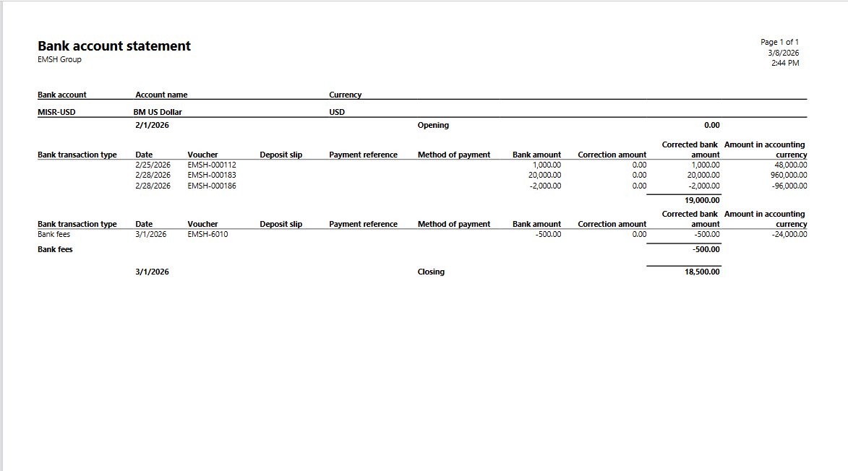
QNB USD
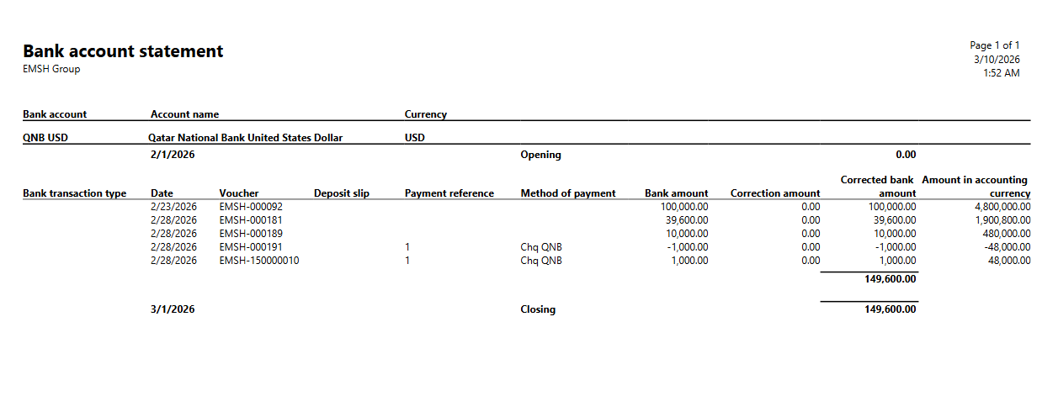
QNB EG

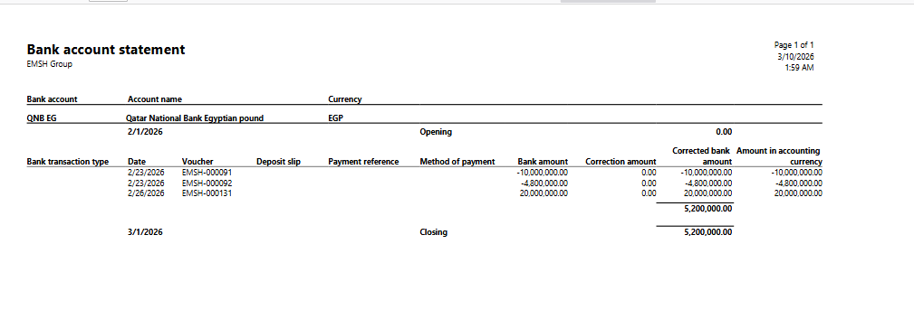

NBE EG
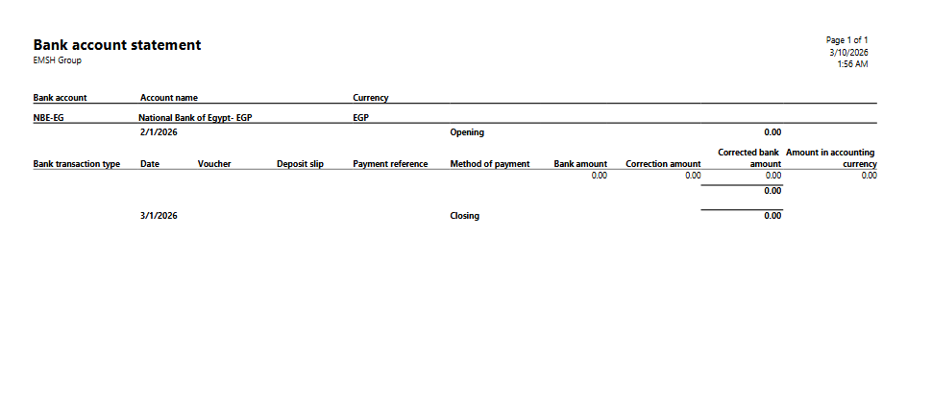

CIB IUSD
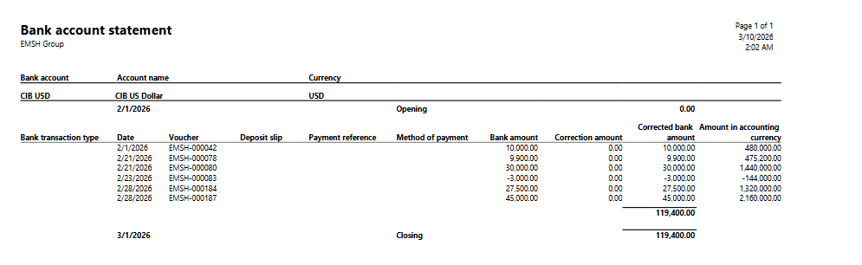

Chq. Payment advices

During invoice settlement transaction using the method of payment of bank checks, the recipient parties from local vendors & governmental entities can receive upon their request payment advices covering all payment details such as :
- Vendor details
- Payer details
- Transaction amount & currency
- Transaction date
- Check number
- Invoice original amount

CIB EG

CHQ # 1 :
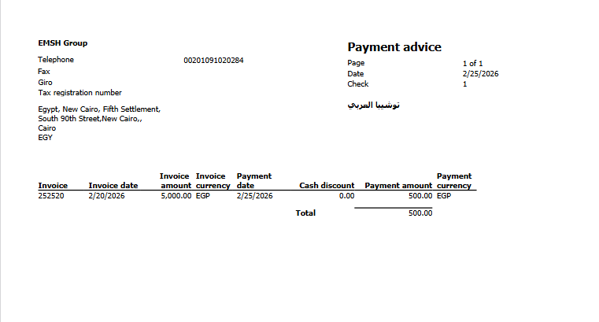
CHQ # 2 :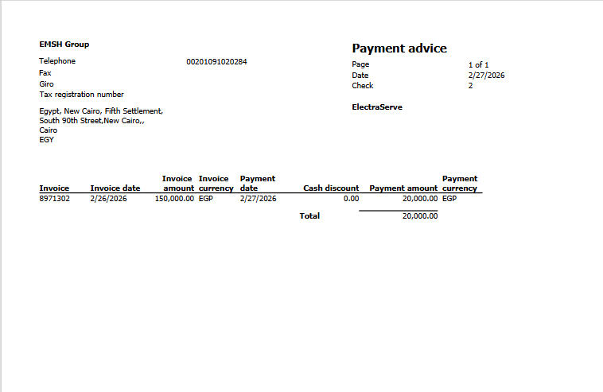

CHQ # 3 :

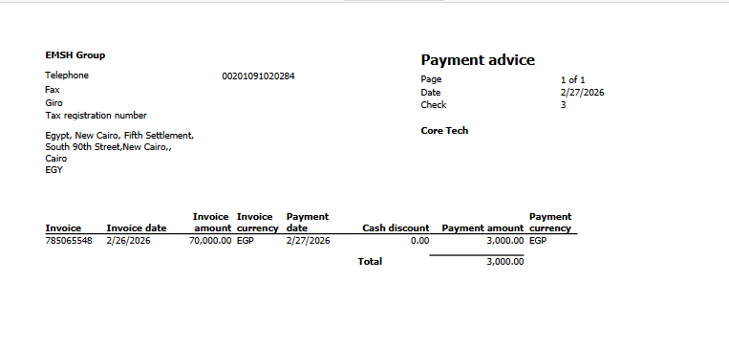

CHQ # 4 :
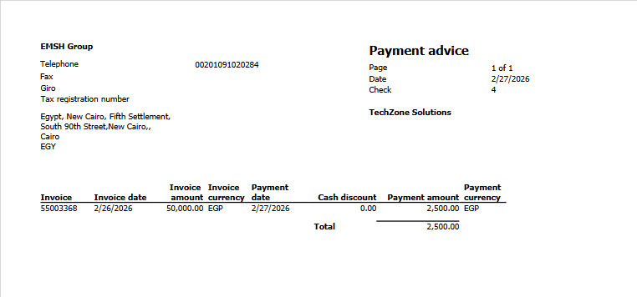

CHQ # 5 :
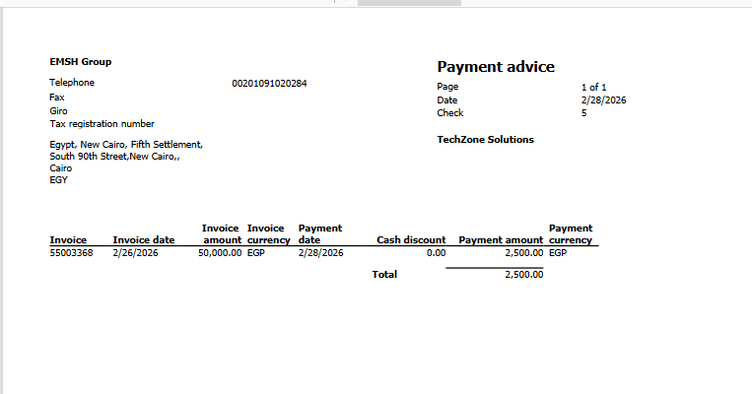

CHQ # 6 :

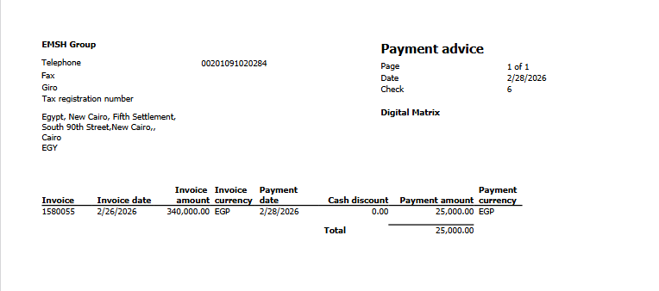

CHQ # 7 :

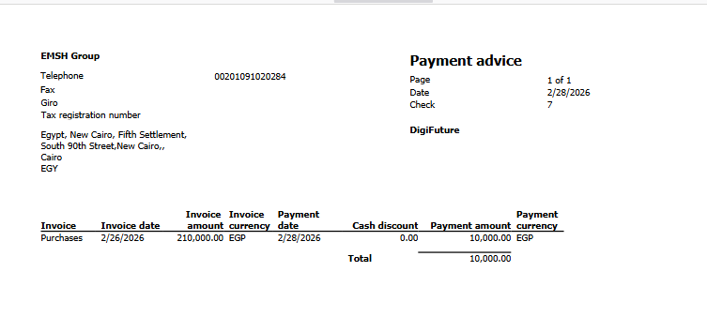

Chq# 8
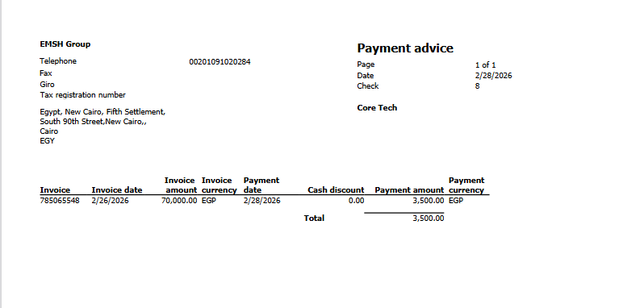

QNB USD

Chq# 1
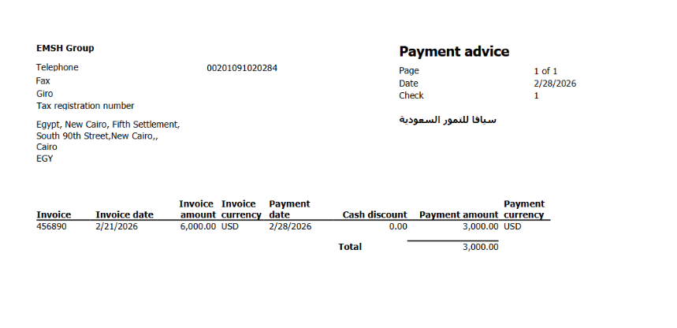

Chq# 2

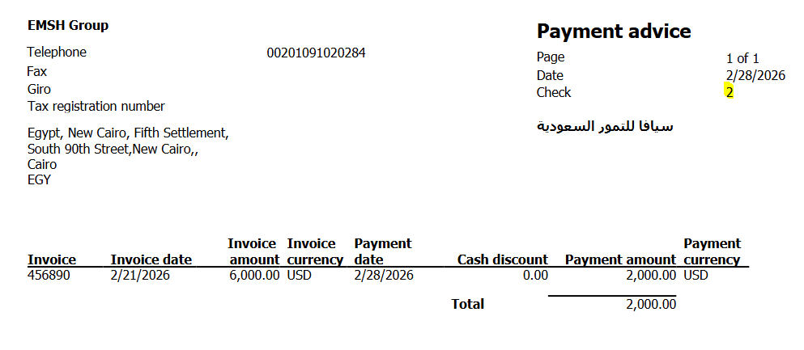

Chq. Print Test

To assure correct formatted check book while processing the chq setup , we need to conduct a check print test
Below is the generated print test document for the issued check book including all check details such as :

- Check date
- Check amount in figures & word
- Check drawer name & details
- Check drawee bame & details
- Account number & narrative
- Check number

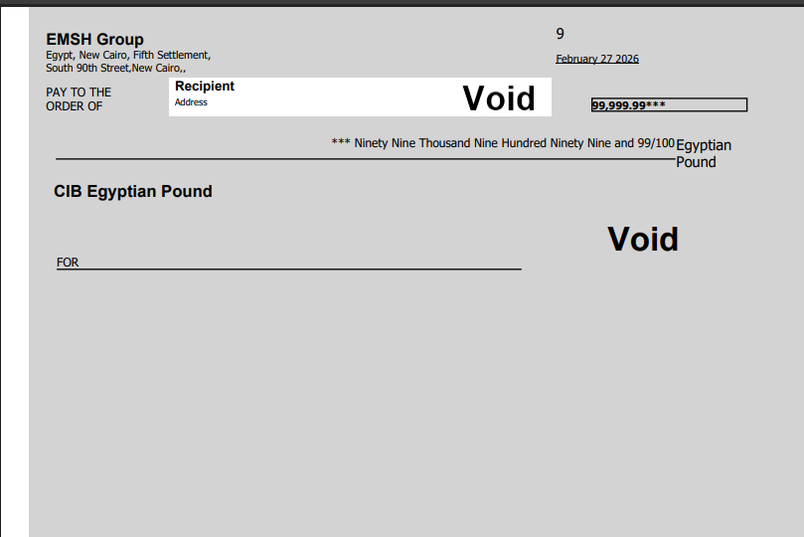

External bank statements

Actual bank transactions are showing on the received bank statement issued by the bank that is being reconciled with system records

Sample of received bank statement is shown as below
